**Assignment 18.2:**

Loading File:







1. Which route is generating the most revenue per year:





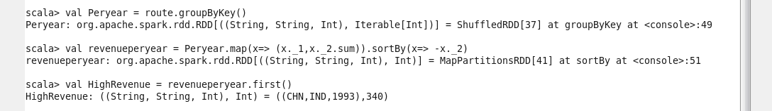

1. What is the total amount spent by every user on air-travel per year:

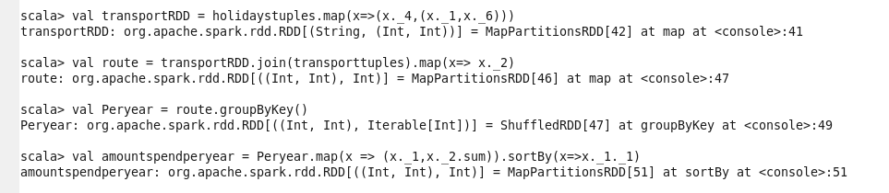

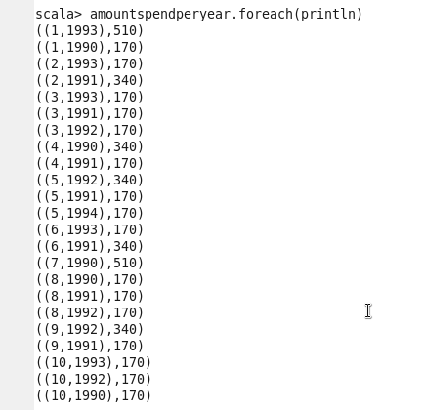

1. Considering age groups of <20 , 20-35 , 35> , which age group is travelling the most every year:



